For Immediate Release:

For additional information, please contact:

Janie Willis

McCrate, DeLaet & Co. CPAs

(937) 492-3161

jwillis@mccrate.com

SIDNEY, OHIO - McCrate, DeLaet & Co., a leading accounting and tax firm located in Sidney, Ohio is pleased to announce new management changes effective October 1, 2016.

Effective September 30, 2016, Managing partner, Dale Schwieterman, CPA, is retiring after 44 years of service to the firm. Dale began his accounting career with the firm right after college. He started as a staff accountant, became a partner in 1977, and then managing partner in 1987. Being raised on a farm, Dale always kept interest in farming and agri-business and served on several committees. He is looking forward to spending more time with his family, helping out with the family farm, and other endeavors.

Tax Partner, David Monnier, CPA, is also retiring from the firm at September 30, 2016 after 42 years of service to the firm. Dave was hired in 1974 as a staff accountant right after college and then promoted to partner in 1987. Dave has served on several committees throughout the community over the years and continues to be involved with Holy Angels Church, Wilson Memorial Hospital, and the Community Foundation of Shelby County. Dave is looking forward to having more free time for family events and his favorite hobby, fishing.

Don Goettemoeller, CPA* is becoming Managing Partner of McCrate, DeLaet & Co effective October 1, 2016.

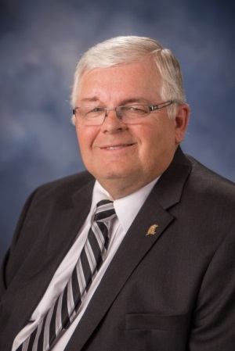
“This month we celebrate the bittersweet transition in our firm. Dale and Dave have spent nearly half a century building this firm and giving back to the community and we are so very grateful for their contribution. David Fortney, CPA and myself will be joined by Sarah Stammen, CPA and Mark Hoge, CPA, CVA, who are being promoted to partners effective October 1, 2016.” said Don Goettemoeller, Managing Partner.

Don Goettemoeller, CPA* has been with the firm since 1978 and became a partner in 1988. He graduated from Miami University with a Bachelor’s Degree in Accounting and Finance. Don is a financial advisor* having passed the FINRA Series 7 and 66 exams and holds insurance licenses for Ohio Life, Accident, and Health and variable products. Don specializes in personal financial planning, nonprofit organizations and employee benefit plans. He also oversees the technology applications for the firm.

Dale Schwieterman, CPA David Monnier, CPA Don Goettemoeller, CPA*
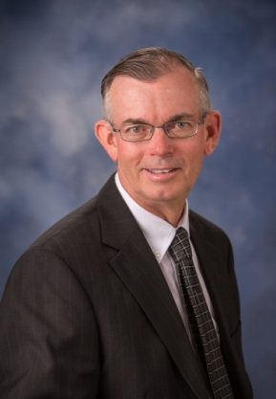
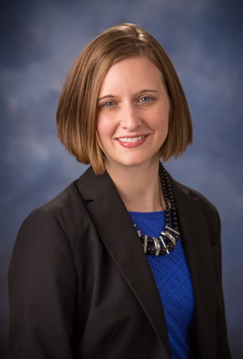
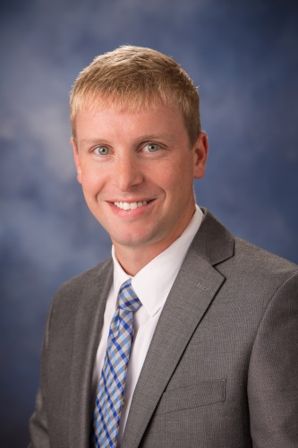
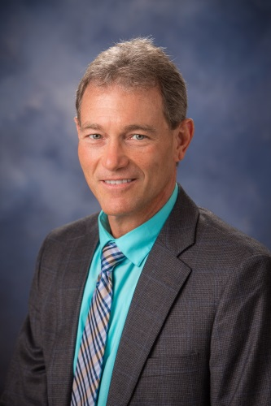
David Fortney, CPA* Mark Hoge, CPA, CVA* Sarah Stammen, CPA*

David Fortney, CPA* has been with McCrate, DeLaet & Co. since 1989 and was promoted to partner in 2008. He graduated from Ohio University with a Bachelor’s Degree in Finance and Accounting. Dave is a financial advisor* having passed the FINRA Series 7 and 66 exams and holds insurance licenses for Ohio Life, Accident, and Health and variable products. Dave’s specialties include agri-business, taxation of estates and trusts, financial planning, and investment advisory services.

Mark Hoge, CPA, CVA* was hired in 2010 after spending six years with a large, national accounting firm. He graduated from the University of Cincinnati with a Bachelor’s Degree in Business Administration and a Master’s Degree in Taxation. He was promoted to Manager in 2012. Mark is a financial advisor* and has passed the FINRA Series 7 and 66 exams as well as the Ohio Life & Health Insurance exam. He is also a Certified Valuation Analyst. His specialties include all areas of taxation, personal financial planning, and valuations of closely held businesses.

Sarah Stammen, CPA* was hired in 2006 after graduating from Bowling Green State University. She earned a Master’s Degree in Accounting with a Taxation Specialization and a Bachelor’s Degree in Business Administration. She was promoted to Manager in 2010. Sarah is also a financial advisor* and has passed the FINRA Series 7 and 66 exams. She also has her QuickBooks online certification. Sarah’s specialties include small businesses, agribusiness, and taxation of individuals, partnerships, and corporations.

About McCrate, DeLaet & Co.
McCrate, DeLaet & Co. is a recognized leader in providing services to agriculture, construction, manufacturing, not for profit, professional, and private clients in the areas of tax, audit and attestation, employee benefit plans, software consulting, business valuations. We partner with 1st Global Capital Corp. for our wealth management services and have five licensed financial advisors*. This partnership allows us to advise clients with retirement and investment planning as well as planning for education and insurance. Our service area includes Auglaize, Darke, Mercer, Miami and Shelby counties with our main office located in Sidney, Ohio. We also have meeting space in Versailles, Ohio and Cassella, Ohio. For more information on McCrate, DeLaet & Co. please visit our website at www.mccrate.co

*Securities offered through 1st Global Capital Corp. Member FINRA/SIPC.
Investment advisory services are offered through 1st Global Advisors, Inc.
Insurance services offered through 1st Global Insurance Services, Inc.

